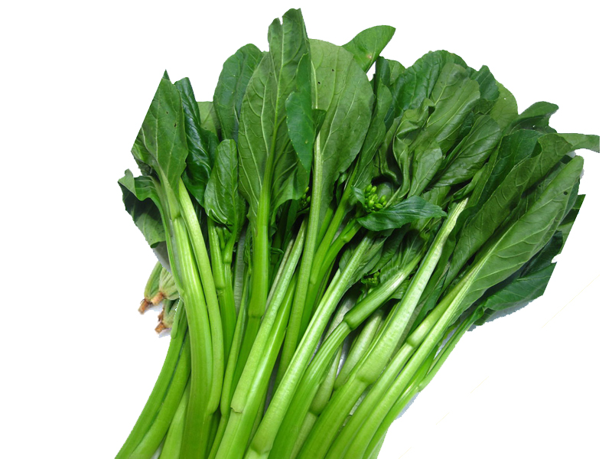Quiz questions

How well do you know fruits and vegetables?

1. What vegetables is this?
   1. Kale
   2. 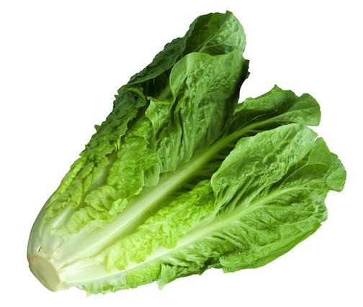Chinese Broccoli
   3. Bok Choi
   4. Yu Choi
2. What vegetables is this?
   1. Lettuce
   2. Cabbage

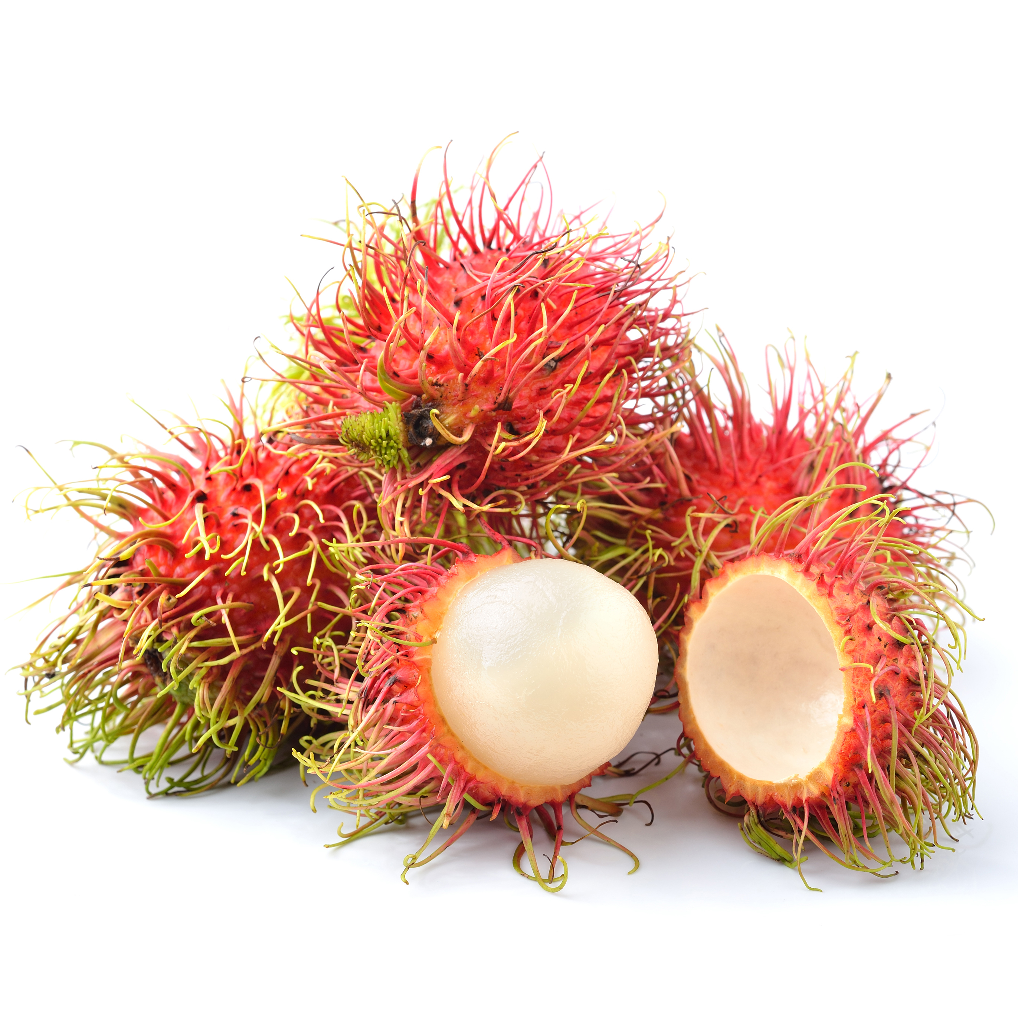

1. What fruits is this?
   1. Mangosteen
   2. Rambutan
   3. Carambola
   4. Soursoup
2. What fruits is this?
   1. Sapodilla
   2. 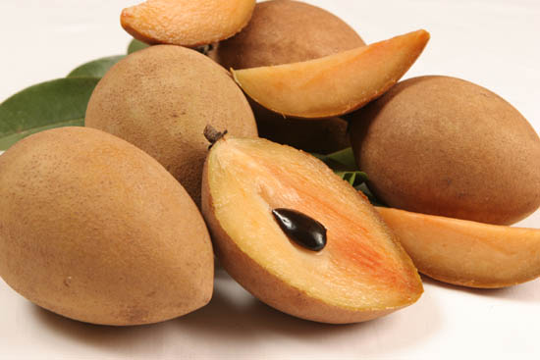Kiwi
   3. Mango
   4. Plum
3. What fruits is this?
   1. Plum
   2. Nectarine
   3. 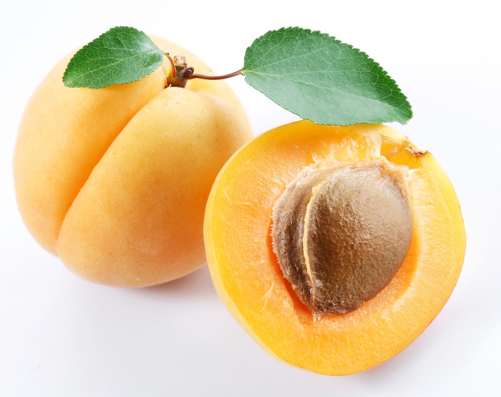Apricot
   4. Mango